Ensembles in Machine Learning
An ensemble is a group of models whose predictions are combined to produce a better result rather than single model
Example
Netflix uses ensembles to recommend movies.
- One model might focus on some preferences, another model on watch time, another on rating. Together, they give better recommendation than any single model

How this helps
- Ensembles reduce variance, bias and improve generalization
Even if individual models are imperfect, their aggregated output is often more accurate

Ensemble strategies
Voting
Stacking
Blending
Boosting
Bagging

Voting
- Democratic prediction
  - Classification: majority vote wins
  - Regression: average of predictions
Stacking
- Meta learning
- Outputs of base models become inputs to a meta-model
- Meta-model learns how to weigh each base model’s prediction

Blending
- A practical variant of stacking
- Use a holdout set instead of cross-validation
- Often used in competitions for quick prototyping
Example –
  - Train base model on 80% of data
  - Use their predictions on the remaining 20% to train a meta-model

Boosting – sequential learning
- Models are trained sequentially
- Each model focuses on correcting the errors of the previous one
- Final model is weighted sum of all weak learners

Example
- AdaBoost: combines weak decision stumps
- Gradient boosting : learns residuals and fits trees to them

Ensembles for Regression
- Voting averaging
- Boosting sequential error correction

Example
- Predict house prices using
  - Random Forest Regressor
  - Gradient Boosting Regressor
  - Linear Regression Combine via averaging

How to build diverse ensembles
- Strategies
  - Different subsets of training data ( ex – bootstrapping)
  - Different hyperparameters ( ex – max depth, learning rate )
  - Different classifiers (ex – K-fold, decision tree)
  - Different features (ex text vs image vs numeric)

Assignment
Design an ensemble to predict student dropout. Choose three models, each trained on different features (like grades, attendance, engagement). And observes or discuss how each contributes

Two pillars or properties of ensembles
- Diversity: models make independent errors
- Acceptability: each model performs better than random guessing

Decision – making in ensembles
- Consider an ensemble of 100 models (ex decision tree, logistic regression etc.,)
- For a binary classification task
  - Each model predicts either 0 or 1
  - The ensemble chooses the majority vote
If > 60 models predict 0, the ensemble output 0. Otherwise it output 1

Robustness against overfitting
- Ensembles are resilient to overfitting
- If one model overfits, others can counterbalance it
- Randomforests are good example
  - Some trees may overfit
  - But unless most trees overfit, the ensemble remains robust

Ex
- Lets say 3 models – m1, m2 and m3
- Each has a 70% chance of being correct
- Use majority voting to predict class (0 or 1)
M1 | M2 | M3 | Ensemble prediction | Probability
Yes | Yes | Yes | Yes | 0.343
Yes | Yes | No | Yes | 0.147
Yes | No | Yes | Yes | 0.147
No | Yes | Yes | Yes | 0.147
Yes | No | No | No | 0.063
No | Yes | No | No | 0.063
No | No | Yes | No | 0.063
No | No | No | No | 0.027

Total probability of correct ensemble prediction = 0.343 + 0.147 + 0.147 + 0.147 = 0.784
It is 78.4% accuracy, compared to 70% for each individual model.

Summary of ensembles
- Pool diverse perspectives
- Reduce variance and overfitting
- Leverage weak learners to form a strong predictor

Ex
Credit score and fraud detection Finance
Banks use ensemble models to assess creditworthiness and detect fraud transaction
Ensembles combining decisions trees, logistic regression and neural networks help to reduce false positives in fraud detection while maintaining high recall
Impact improved risk assessment and reduced financial losses

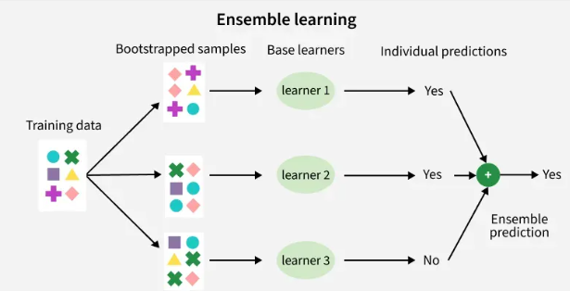

Bagging – models are trained independently on different random subsets of the training data. Results are combined by averaging or voting

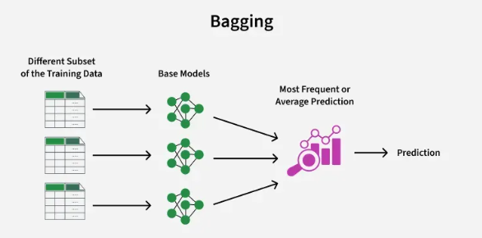

Boosting
Models are trained one after another. Each new model focuses on fixing errors of previous one.
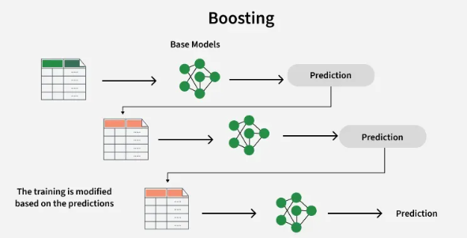

Stacking – multiple diff models are trained and their predictions are used as inputs to final model / meta model
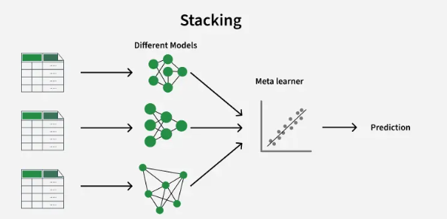

Random Forests

- One of machine learning algorithm
- It uses many decision trees to make better pedictions, each tree considers at diff random parts of the data and their results are combined by voting or averaging

Algorithm
- Create many decision trees
- Pick random features / verity the features and then split the data
- Each tree makes a prediction based on its learning
- Combine the predictions

How it helps
- High accuracy – combines many trees to reduce variance and improve predictions
- Robust to overfitting – randomness in data and features helps to generalize
- Handles missing data: even there’re some missing – it works well
- Feature importance – it can rank features by importance

Bagging and bootstrapping
- Bagging – bootstrap aggregating
- Bootstrapping – sampling
  - Each sample contains 40 to 70% of the original data
- Aggregation – combining predictions from all trees

Assignment create 3 bootstrap samples from a small dataset. Train 3 decision trees and compare their predictions

Feature randomness
- Random forests also select random subsets of features when splitting nodes
  - This prevents dominant forests from biasing all trees
  - Ensures diversity among trees

Key features
- It can work even when some data is missing
- Shows the feature importance/ it shows what features are useful
- Works well with complex data
- It can use for both classification and regression

Assumptions
- Each tree makes its own decision
- Random data are use
- Enough data is needed
- Different predictions improved accuracy

OOB error
- Out of bag error
  - Each tree is trained on a subset of data
  - Use the remaining data (not seen by the tree) to test it
- Saves the need for separate test set

